The Stopping and Range in Compounds
Soon after the discovery of energetic particle emission from radioactive materials, there was interest how these corpuscles were slowed down in transversing matter. In 1900 Marie Curie stated: "Les rayons alpha sont des projectiles materiels susceptibles de perdre de leur vitesse en traversant la matière." [1] Scientists realized that since these particles could penetrate thin films, experiments measuring their energy loss and scatter might finally unravel the secrets of the atom. Bragg and Kleeman started to conduct such experiments with a radium source in 1903, but were unable to find many types of thin films, since there were no "goldbeaters" in Australia. So they studied the energy loss of alpha particles in hydrocarbon gases such as methyl bromide and methyl iodide to find how alpha stopping depended on the atomic weight of the target. They removed the stopping contribution of hydrogen and carbon atoms in the hydrocarbon target gases by a subtraction of the stopping power in equivalent pure carbon and hydrogen targets. From their analysis in 1905, comes Bragg's Rule that the stopping of a compound may be This rule is reasonably accurate, and the measured stopping of ions in compounds usually deviates less than 20% from that predicted by Bragg's rule. The accuracy of Bragg's rule is limited because the energy loss to the electrons in any material depends on the detailed orbital and excitation structure of the matter, and any differences between elemental materials and the same atoms in compounds will cause Bragg's rule to become inaccurate. Further, any bonding changes may also alter the charge state of the ion, thus changing the strength of its interaction with the target medium.
Figure 1 : Atom Stopping in Simple Compounds
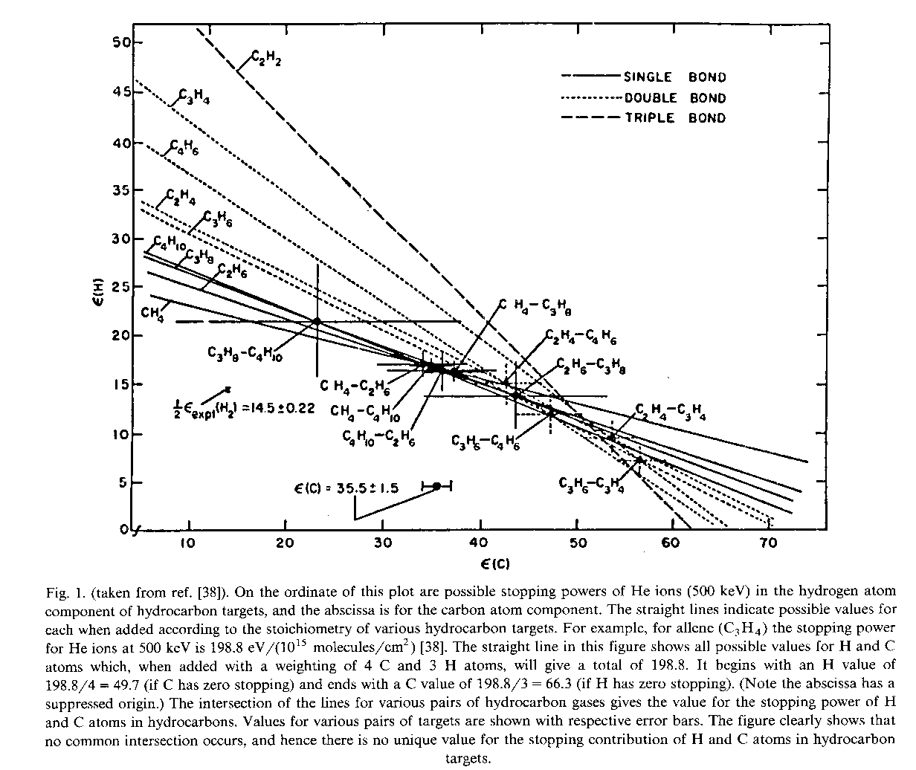
Experimental studies of Bragg's rule started in the 1960s, and wide discrepancies were found from simple additivity of stopping powers. See Figure 1. for an example of H and C non-additivity in simple hydrocarbons as estimated by the linear combination of the stopping powers of individual elements.[2] .[3]. In this figure, the stopping in various hydrocarbons is taken for pairs of compounds, and the relative contribution of H and C is extracted (solving two equations with two unknowns). It is found that the relative contribution of H and C differs by almost 2x over the range of compounds. Similar work studied more complex hydrocarbons but instead of adding H and C bonds, they added extra hydrocarbon molecules. In this study, they found that by adding molecules to hydrocarbon strings, stopping linearity returned.[4]. See Figure 2. Adding new molecules just scaled the stopping by the extra number of atoms. These results showed that atomic bonding had large effects on stopping powers of simple molecules while extra agglomeration of molecules had a small stopping effect.
Since these early experiments, theorists have shown that extensive calculations can predict the stopping of light ions (usually protons) in hydrocarbon compounds. Much of this work has been based on a seminal paper by Peter Sigmund that developed methods to account for detailed internal motion within a medium.[5] This theory allows for arbitrary electronic configurations in the target. Sabin and collaborators used this approach to calculate stopping powers for protons in hydrocarbons with good success.[6] Sabin's calculation follows what is sometimes called the Köln Core and Bond (CAB) approach which is discussed in detail below.
Figure 2 : Molecule Stopping Large Compounds
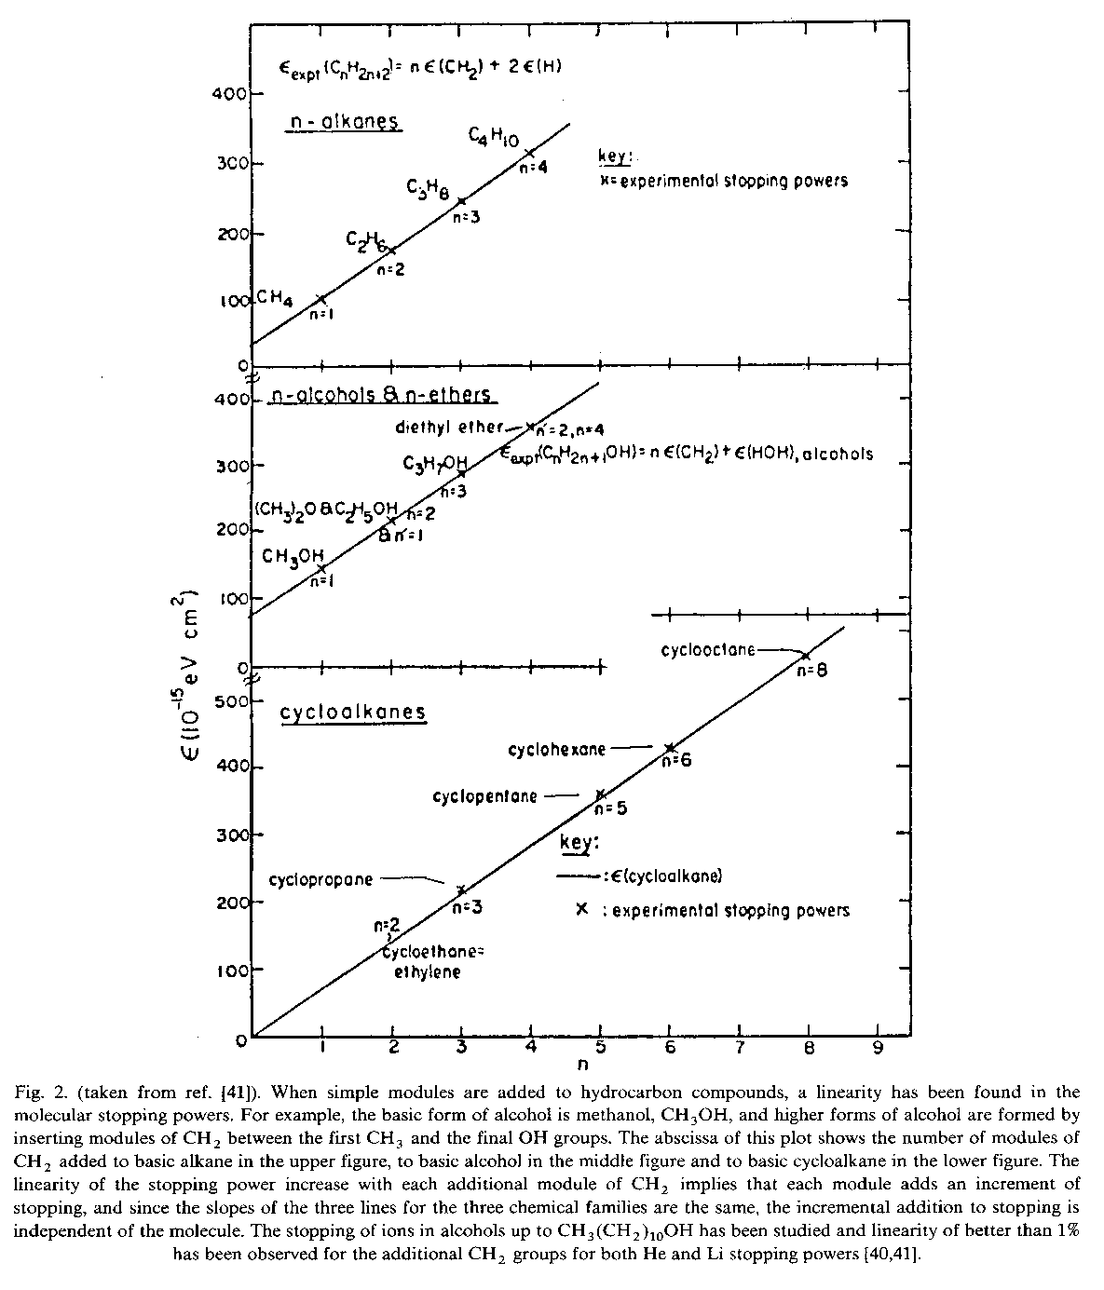
We are not going to review the complex theoretical work on stopping in compounds. Our interest is to try to find a simple way to estimate the changes that compounds introduce to the use of Bragg's rule to generate stopping powers of compounds. For the general user of SRIM, with only a minimal knowledge of the physics of stopping theory, we need a simple method to estimate bonding corrections to stopping.
The Core and Bond (CAB) approach suggested that stopping powers in compounds can be predicted using the superposition of stopping by atomic "cores" and then adding the stopping due to the bonding electrons.[7] The core stopping would simply follow Bragg's rule for the atoms of the compound, where we linearly add the stopping from each of the atoms in the compounds. The chemical bonds of the compound would then contain the necessary stopping correction. They would be evaluated depending on the simple chemical nature of the compound. For example, for hydrocarbons, carbon in C-C, C=C and C=t=C structures would have different bonding contributions (C=C indicates a double-bond structure and C=t=C is a triple bond). The contribution to stopping by a carbon atom in a C=C bond is almost twice that of a carbon atom single-bond state. And a carbon atom in a triple-bond state contributes even greater stopping powers. See Figure 3. By merely specifying the bonding of the atoms in the compound, for example, SRIM can then generate a stopping correction required for the compound with this bonding arrangement.
SRIM uses this approach to generate corrections between Bragg's rule and compounds containing the common elements in compounds: H, C, N, O, F, S and Cl. These light atoms have the largest bonding effect on stopping powers. Heavier atoms are assumed not to contribute anomalously to stopping because of their bonds (discussed later). When you use SRIM, you have the option to use the Compound Dictionary which contains the chemical bonding information for about 150 common compounds. The compounds with corrections are shown with a Star symbol next to the name. When these compounds are selected, SRIM shows the chemical bonding diagram and calculates the best stopping correction. The correction is a variation from unity (1.0 = no correction). Notice that carbon atoms have almost a 4x change in stopping power from single bonds to triple bonds. This large change indicates the importance of making some sort of correction for the stopping of ions in compounds.
Figure 3 : Core & Bonds
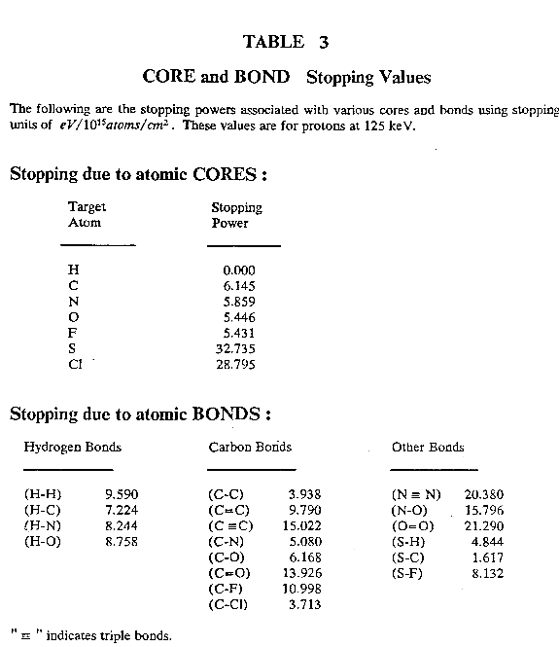
The CAB approach that SRIM uses has been tested on more than 100 compounds, from 162 experiments (discussed later). SRIM correctly predicts the stopping of H and He ions in compounds with an accuracy of better than 2% at the peak of the stopping curve, ~125 keV/u.
You can introduce other compounds to SRIM by adding to the Compound Dictionary. You need to edit the SRIM file ..\Data\COMPOUND.dat. Instructions are at the top of the file, and included are more than 150 examples to guide you in creating your own compounds. SRIM will use your chemical bonding information to calculate the stopping correction. SRIM can only calculate bonding of the seven elements: H, C, N, O, F, S and Cl. Any other elements will be assumed to have the same stopping as in their elemental form.
Details of how SRIM calculates the bonding correction to stopping can be found in the paper: J. F. Ziegler and J. M. Manoyan, Nucl, Inst. Methods, B35, 215-228 (1988).
[1] Mme. Pierre Curie, C. R. Acad. Sci., 130, 76 (1900).
[2] W. H. Bragg and R. Kleeman, Philos. Mag., 10, 318 (1905)
[3] A. S. Lodhi and D. Powers, Phys. Rev., A10, 2131 (1974).
[4] D. Powers, Acc. Chem. Res., 13, 433 (1980).
[5] P. Sigmund, Phys. Rev., A26, 2497 (1982).
[6] J. R. Sabin and J. Oddershede, Nucl. Inst. Methods, B27, 280 (1987).
[7] G. Both, R. Krotz, K. Lohman and W. Neuwirth, Phys. Rev., A28, 3212 (1983).

Core and Bond Corrections
There have been more than 400 papers which discuss methods of calculating the stopping of ions in compounds (Compound Citations listings). Many recent papers tend to be rather rigorous and apply molecular orbital calculations to single systems. Our interest is to find an accurate solution which can be used for any ion / compound situation with limited input from the user. The most basic information is still necessary: the chemical nature of the compound. From this rudimentary information, SRIM then estimates the corrections needed to produce stopping which is accurate to a few percent. (SRIM's input requirements are discussed below.)
The method which is used is called the Core and Bond (CAB) approach, which was first proposed by a group at the University of Cologne (Köln, Germany).[1] They proposed approaching the problem by reducing each target atom to two parts: the core electrons which are unperturbed by bonding, and the bonding electrons. An example would be for carbon atoms, with a core of the nucleus and the inner shell electrons, and then separate outer shell contributions depending on how the carbon was bound into the compound.
The problem is to determine the Core and Bond values for common elements. The Core stopping contributions would simply follow Bragg's rule for the atoms of the compound, which suggests a linear addition of the stopping from each of the elements in the compound. The chemical bonds of the compound would then contain a correction to this basic stopping. The bonds would be evaluated depending on the simple chemical nature of the compound. For example, for hydrocarbons, carbon in C-C, C=C and C⇨C structures would have different bonding contributions (C=C indicates a double-bond structure and C⇨C is a triple bond). The contribution to stopping by a carbon atom in a C=C bond is almost twice that of a carbon atom single-bond state. And a carbon atom in a triple-bond state contributes even greater stopping powers. By merely specifying the bonding of the atoms in the compound, for example, SRIM can then generate a stopping correction required for the compound with this bonding arrangement.
The Core and Bond values may be determined by analyzing the stopping of ions over a great number of targets, and solving for the contribution from the Cores and the Bonds. We use the stopping of light ions, H, He and Li, in 162 different stopping experiments. The compounds contained 30 different elements. We will assume that for the targets with 12 heavy elements, the stopping is dominated by the non-bonding electrons (discussion below). But 114 of these compounds contained only light elements, and their stopping is significantly altered by their bonding. The light elements we consider are: H, C, N, O, F, S and Cl. For each of these elements there is a core contribution, and a separate bonding contribution. The bonds which appear in the 114 compounds with only light elements that we studied were:

Compound Bonds which were Evaluated

(Table 1)
Hydrogen  Bonds |  | Carbon  Bonds |  | Other  Bonds
H-H |  | C-C |  | N⇨N
H-C |  | C=C |  | N-O
H-N |  | C⇨C |  | O=O
H-O |  | C-N |  | S-H
H-S |  | C-O |  | S-C
 |  | C=O
 |  | C-F
 |  | C-Cl
where "-" denotes a single bond, "=" denotes a double bond and "⇨" denotes a triple bond. These 16 bonds are considered unknown parameters. The scaling of ion stopping from H to He to Li are also considered unknowns. Finally the stopping effect of the phase-state of the target is another unknown parameter. This gives a total of (16 bonds) + (3 ions) + (2 phase states) = 20 parameters that will be extracted from the data of 114 experiments. For H in targets, we assume there is no core (only one electron is available) and all its stopping is in the bonding electron. For the other elements, each possible bond is considered separately.
It is clear that we have an "over-defined" problem, in which there are many more equations than the number of unknowns, and this improves the accuracy of the solutions. The solving of the multiple equations was done in a standard iterative method for over-defined problems.
The limitations of this approach should be mentioned.
- The most important limitation might be that of the target band-gap. Experiments on insulating targets dominate the experimental results that we use. For compounds which are conducting, there might be an error with the suggested stopping correction. It might be too low. Theoretically, band gap materials are expected to have lower stopping powers than equivalent conductors because the small energy transfers to target electrons are not available in insulators. It is not clear what the magnitude of this effect is, but about 50 papers have discussed the stopping of ions in metals and their oxides, e.g. targets of Fe, Fe₂O₃ and Fe₃O₄. (Examples are shown below: Bragg's Rule and Heavy Elements) These experiments evaluated similar materials with and without band-gaps. No significant differences were found that could be attributed to the band-gap. Measurements have also been made of the stopping of H and He ions into ice (solid water) with various dopings of salt (NaCl). No change of energy loss was observed for up to 6 orders of magnitude change in resistivity of the ice.
- The scaling of ion stopping from H to He to Li is assumed to be independent of target material, This assumption has been evaluated with 27 targets which have been measured for two of the three ions (at the same ion velocity) and 6 of these targets have been measured for all three ions (see listings in Table 2). In all cases, the stopping scaled identically within 4%. That is, for H (125 keV) and He (500 keV) and Li (875 keV) the scaling of stopping powers was 1 : 2.7 : 4.7 for the 27 targets (average error was <4%). (For those unfamiliar with stopping theory, the primary parameter for the scaling of stopping powers is the ion velocity, which reduces to scaling in units of kev/amu. This is reviewed in the section on Stopping History.)
- The light elements of He and Ne are missing from the above list of target bonding atoms. No comparative experiments have been done on the stopping into He in solid / gas phases. However studies of stopping into targets of Ne and Ar have been conducted in both gas and solid form. These papers show no significant difference between the stopping in gas and solid phases. It appears that the van der Waals forces which hold noble gases together in frozen form, are too weak to effect the energy loss of ions. Of particular note is the extensive work done in the paper: F. Besenbacher, J. Bottiger, O. Graversen, J. Hanse and H. Sorensen, "Stopping Power of Solid Argon for Helium Ions", Nucl. Inst. Methods, 188, 657-667 (1981).
- The light target atoms of Li, Be and B are missing from the list of bonding atoms. This is a serious defect. The number of papers that have looked at compounds which contain significant amounts of these three elements is too limited to allow their evaluation. Target atoms of these three elements are considered by SRIM to have no bonding correction, which is clearly not true. But without experimental data, there is no reliable way to evaluate the contribution of their bonds in compounds.
Reference [1] G. Both, R. Krotz, K. Lohman and W. Neuwirth, Phys. Rev., A28, 3212 (1983).
Table 2 shows the compounds used for the extraction of Core and Bond parameters.

Compounds used to extract Bonding Contributions (Table 2)
Compound | Formula | Ions |  | Compound | Formula | Ions
Acetaldehyde | C₂H₄O | He |  | Ethylene | C₂H₄ | H, He, Li
Acetic Acid | CH₃COOH | Li |  | Ethylene oxide | C₂H₄O | He
Acetone | C₃H₆O | He, Li |  | Ethylene sulfide | C₂H₄S | He
Acetylene | C₂H₂ | H, He |  | Formic Acid | HCOOH | Li
Alcohol, methyl- | CH₃OH | He, Li |  | Glycerol | C₃H8O₃ | Li
Alcohol, ethyl- | C₂H5OH | He, Li |  | Hydrogen Sulfide | SH₂ | He
Alcohol, propyl- | C₃H7OH | He, Li |  | Methane | CH₄ | H, He
Alcohol, undecanol- | C₁₁H₂₃OH |  |  | Methane, chloro-trifluoro- | CClF₃ | He
Allene | C₃H₄ | He |  | Methane, dichloro-difluoro | CCl₂F₂ | He
Aluminum oxide | Al₂O₃ | H, He, Li |  | Methane, dichloro-fluoro- | CHCl₂F | He
Ammonia | NH₃ | H |  | 2-Methyl, 1,3-butadiene | C₅H₈ | Li
Anthracene | C₁₄H₁₀ | H |  | Methyl sulfide | (CH3)₂S | He
Benzene | C₆H₆ | H, He, Li |  | Nickel oxide | Ni₂O₃ | H, He
Bicyclo[221]hepta2,5diene | C₇H₈ | Li |  | Nitrous oxide | N₂O | H, He
Butane | C₄H₁₀ | He |  | Octanoic acid | C₇H₁₅COOH | Li
1,30Butadiene | C₄H₆ | He |  | n-Pentane | C₅H₁₂ | Li
2-Butanone | C₄H₈O | He |  | N-Pentadecane | C₁₅H₃₂ | Li
Butyraldehyde | C₄H₈O | He |  | 1,5-Pentanediol | C₅H₁₂O₂ | Li
Carbon tetrachloride | CCl₄ | He |  | 3-Pentanone | C₅H₁₀O | He, Li
Carbon tetrafluoride | CF₄ | He |  | 1-Pentene | C₅H₁₀ | Li
1-Chlorobutane | C₄H₉Cl | Li |  | Phenylacetylene | C₈H₆ | He
1-Chloroheexadecane | C₁₆H₃₃Cl | Li |  | Polyethylene | (CH₂)_{n} | H
1-Chlorohexane | C₆H₁₃Cl | Li |  | Polypropylene | (C₃H₆)n | H
2-Chloro-2-methylpropane | C₄H₉Cl | Li |  | Polystyrene | (C₈H₈)n | H, He
1-Chloropropane | C₃H₇Cl | Li |  | Propane | C₃H₈ | H, He
1,3,5-Cycle-heptatriene | C₇H₈ | Li |  | 1,3-Propanediol | C₃H₈O₂ | Li
1,3-Cyclo-hexadiene | C₆H₈ | He |  | 2-Propanol | C₃H₇NH₂ | Li
Cyclohexane | C₆H₁₂ | He, Li |  | Propylamine | C₃H₇NH₂ | Li
Cyclohexanone | C₆H₁₀O | He |  | Propylene | C₃H₆ | H, He
Cyclohexene | C₆H₁₀ | He, Li |  | Propylene oxide | C₃H₆O | He
Cyclooctane | C₈H₁₆ | He, Li |  | Propylene sulfide | C₃H₆S | He
Cyclopentane | C₅H₁₀ | He, Li |  | Silicon dioxide | SiO₂ | H, He, Li
Cyclopentene | C₅H₈ | He, Li |  | Thiophene | C₄H₄S | He
Cyclopropane | C₃H₆ | H, He |  | Toluene | C₇H₈ | He, Li
n-Decane | C₁₀H₂₂ | Li |  | Trimethylene sulfide | C₃H₆S | He
1,2-Difluorethane | C₂H₄F₂ | He, Li |  | Water (solid) | H₂O | H, He, Li
p-Dioxane | C₄H₈O₂ | He |  | Water (gas) | H₂O | H, He, Li
Ethane | C₂H₆ | He |  | Hydrogen (gas) | H₂ | H, He
1,2-Ethanediol | (CH₂OH)₂ | Li |  | Nitrogen (gas) | N₂ | H, He
Ethane hexafluoride- | C₂F₆ | He |  | Oxygen (gas) | O₂ | H, He
Ethane hexafluoride | C₂F₆ | He |  | Graphite | C₆ | H, He
Ether, dimethyl- | C₂H₆O | He
Ether, vinyl-methyl- | C₃H₁₀O | He
Ether, diethyl- | C₄H₁₀O | He, Li
The simultaneous fitting of ion stopping in all of these compounds yielded the following Bonding Corrections, see Table 3. The corrections are for H, He and Li ions at 125 keV/amu (about the peak of their stopping power curve) and all strengths are normalized to the C-C bond. The evaluations were done at several ion velocities, both higher and lower than 125 keV/amu, and the relative magnitude of the bonds changed. The spread of the relative effects was significantly reduced for higher ion energies. For lower energies, the spread of relative strengths slightly increased, but not very much.

Relative Strength of Bonding in Compounds (Table 3)
Hydrogen  Bonds | Relative  Strength |  | Carbon  Bonds | Relative  Strength |  | Other  Bonds | Relative  Strength
H-H | 2.44 |  | C-C | 1.00 |  | N#N | 5.17
H-C | 1.83 |  | C=C | 2.49 |  | N-O | 4.01
H-N | 2.09 |  | C#C | 3.81 |  | O=O | 5.40
H-O | 2.22 |  | C-N | 1.29 |  | S-H | 1.23
H-S | 1.23 |  | C-O | 15.7 |  | S-C | 0.41
 |  |  | C=O | 3.53
 |  |  | C-F | 2.79
 |  |  | C-Cl | 0.94
The relative strength of the target atom "cores" were also extracted, see Table 4. The contribution of the hydrogen core was set to zero because its only electron is used in bonding. All core strengths are shown relative to carbon. The core contribution to stopping was found to be relatively independent of the ion velocity, in contrast to the contribution of bonding, above.

Relative Strength of Atomic Cores (Table 4)
Target Atom | Relative Core  Strength
Hydrogen | 0.000
Carbon | 1.000
Nitrogen | 0.93
Oxygen | 0.89
Fluorine | 0.88
Sulphur | 5.33
Chlorine | 4.69

Bragg's Rule and Heavy Target Elements
We have concentrated on the analysis of the stopping of ions in compounds made up of light elements. For compounds with heavier atoms, many experiments have shown that deviations from Bragg's rule disappear. In Table 5 are shown representative examples of ion stopping in various compounds containing heavy elements. None show measurable deviations from Bragg's rule. The citations for these measurements are tabulated in the Compound Citation page. Many articles with similar results were reviewed in the 1980s.[1,2]

Bragg's Rule Accuracy in Heavy Compounds (Table 5)
Compound | Deviation from  Bragg's rule |  | Compound | Deviation from  Bragg's rule |  | Compound | Deviation from  Bragg's rule
Al₂O₃ | < 1% |  | HfSi₂ | < 2% |  | Si₃N₄ | < 2%
Au-Ag alloys | < 1% |  | NbC | < 2% |  | Ta₂O₅ | < 1%
Au-Cu alloys | < 2% |  | NbN | < 2% |  | TiO₂ | < 1 %
BaCl₂ | < 2% |  | Nb₂O₅ | < 1% |  | W₂N₃ | < 2%
BaF₂ | < 2% |  | RhSi | < 2% |  | WO₃ | < 2%
Fe₂O₃ | < 1% |  | SiC | < 2% |  | ZnO | < 1%
Fe₃O₄ | < 1%
For compounds which contain elements with atomic numbers greater than 12, it is possible to combine the CAB approach with Bragg's rule. The CAB approach can be used for the small atomic number cores and bonds, and these can be combined with the normal stopping contribution of the other components of the compound.
[1] D. I. Thwaites, Nucl. Inst. Methods, B12, 84 (1985).
[2] D. I. Thwaites, Nucl. Inst. Methods, B27, 293 (1987).

Examples of Stopping Correction for Compounds

Stopping Correction for a target of Ethylene
When you use SRIM, you are given the option of using the Compound Dictionary. This menu lists about 200 compounds, and provides stopping corrections for a great number of them. Below is a typical example for Ethylene, C₂H₄, which has a total 12% stopping correction. Below on the left is the SRIM Compound Dictionary window for Ethylene. The Bonding Correction is 8.33%. Below this is the density for Ethylene in gas phase, and the chemical formula and the bonding information in schematic form. Below this is the composition of Ethylene in both atomic percent and mass percent. The term "Core Stopping" is the same as the Table 4 above, but in different units. Finally, at the bottom the bonding information is listed. There are four (H-C) single bonds, and one (C=C) double bond. The effect of these cores and bonds is to make a 8.3% correction. SRIM also makes an automatic correction for the phase change for carbon in the target if the "Gas Phase" box is checked in SRIM (we are assuming gaseous Ethylene in this example). The gas-phase correction is about 4% for carbon. This makes the total correction to be 12%. Shown in figure He into Ethylene (gas) is the stopping of He ions into Ethylene showing the Bragg's rule stopping estimate for (2 Carbon) + (4 Hydrogen) atoms (black curve). These values are clearly too small. There are two corrections that are made. The stopping of He in Carbon assumes a solid-phase target. The stopping in gas-phases usually increases the stopping. Shown in the curve is the stopping due to carbon solid (solid green line) and carbon in gas phase (dashed green line). Then we must consider the bonding effects. The ethylene molecule contains 4 H-C single bonds, and a C=C double bond. From the discussion above, the C=C bond adds significantly to the stopping power near the peak of the stopping. SRIM calculates that this increase is 8.3%. So the two corrections make the total adjustment to the stopping to be about 12%, and it brings the calculation into reasonably accurate agreement with the data.

Extensive plots of stopping in Compounds, as well as citations to more than 200 scientific papers which have discussed the stopping of ions in compounds, may be found at the website:

http://www.srim.org/SRIM/Compounds.htm

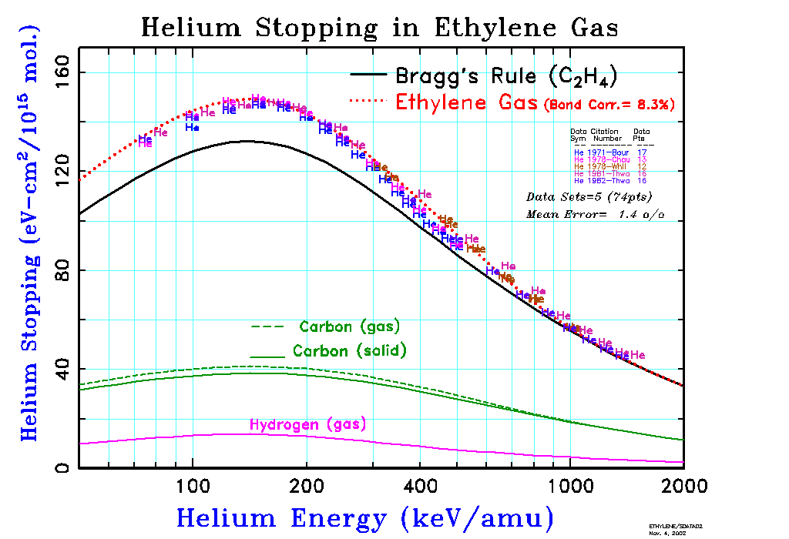
Ethylene
Stopping Correction for Target Chemistry
Solid Target = +10.79%
Gas Target = + 3.04%
=======================================
Density = 0.00125 g/cm3
Chemical H H
Formula \ /
C == C
C H / \
2 4 H H
------ TARGET COMPOSITION --------
Atom Atom Number Atom Core
Name Numb Atoms Mass % Stopping
---- ---- ------- ------ --------
H 1 4.00 14.37 0.00
C 6 2.00 85.63 6.21
-TARGET BONDS (per molecule)-
Bond Type Number Stopping
--------- ------ --------
(H-C) 4 7.438
(C=C) 1 10.023

Stopping Correction for a target of Polystyrene
Another example of a large correction is that necessary for a target of Polystyrene, C₈H₈. Shown below is the Compound Dictionary in SRIM for Polystyrene (which is also identified by the ICRU #226). This compound will have two corrections, one to convert stopping in H (gas) to stopping in H (solid). This will tend to decrease the stopping power. The second correction will be for the bonding of the compound, which will increase the stopping. The result will be a net increase of about 6%. The chemical form of Polystyrene is rather complex since it contains 8 (H-C) bonds, 6 (C-C) bonds and 3 (C=C) bonds. Note that the density of Polystyrene is quite variable, and you must be careful that your target density is correctly entered.
Shown in figures "H into Styrene" and "He into Styrene" are the stopping of H and He ions into Polystyrene. They show the Bragg's rule stopping estimate for (8 Carbon) + (8 Hydrogen) atoms (black curve). These values are too small. There are two corrections that must be made. The stopping of ions in Hydrogen assumes a gas-phase target. The stopping in gas-phases has higher stopping than for solid phase. Shown in the curve is the stopping due to hydrogen in gas phase (dashed green line) and hydrogen solid (solid green line). Then we must consider the bonding effects. The Polystyrene molecule contains 8 H-C single bonds, 6 C-C single bonds, and 3 C=C double bonds (see the molecular structure in SRIM's Compound Dictionary). From the discussion above, the C=C bond adds significantly to the stopping power near the peak of the stopping. SRIM calculates that the bonding correction is +6.6%. In this case the two corrections work opposite to each other. The phase-change correction for hydrogen reduces the stopping, while the bond correction increases the stopping. The total adjustment to the stopping is about 6%, and it brings the calculation into reasonably accurate agreement with the data for both H and He ions.
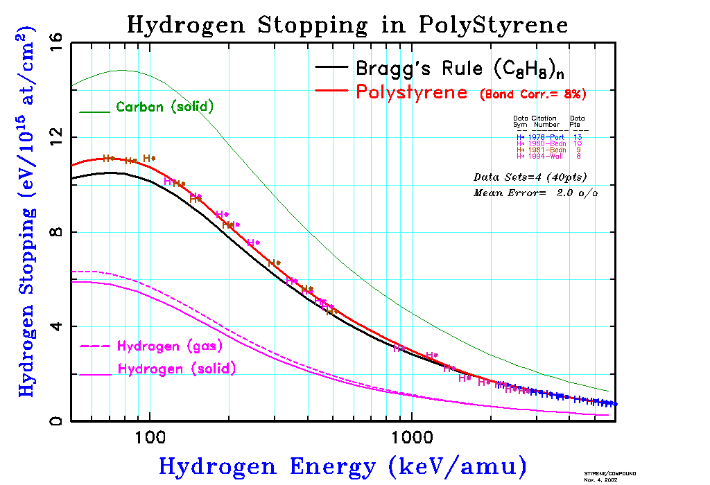
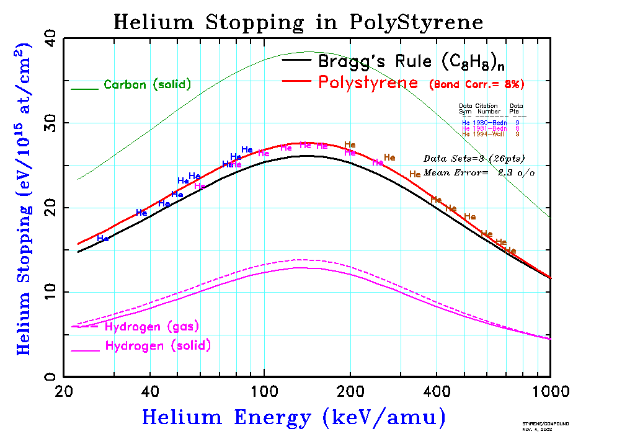

SRIM Compound Stopping Correction
Polystyrene (ICRU-226)
Stopping Correction for Target Chemistry
Solid Target = +8.59%
Gas Target = +0.99%
=======================================
Density = 1.06 g/cm3
Chemical H – C - C - H
Formula / \ |
H - C C - C - H
|C H | \\ // |
| 8 8|n C - C H-C-H
| | |
H H |
Density ranges from 0.98 to 1.075 g/cm3.
-------- TARGET COMPOSITION ---------
Atom Atom Number Atom Core
Name Numb Atoms Mass % Stopping
---- ---- -------- ------- --------
H 1 8.00 7.74 0.00
C 6 8.00 92.26 6.21
-TARGET BONDS (per molecule)-
Bond Type Number Stopping
--------- ------ --------
(H-C) 8 7.438
(C-C) 6 3.964
(C=C) 3 10.023

